**Title:** Personal’s occupation details

**Name(s):** Kasitphoom Thowongs

Student number(s): 65011328

email address(es): [65011328@kmitl.ac.th](mailto:65011328@kmitl.ac.th), [kasitphoom47@gmail.com](mailto:kasitphoom47@gmail.com)

**Collaborator(s):** -

**Aim:**To use a trait of structure in Rust programming which use an example of people’s occupations details.

**Methods:**

1. Tools:
   1. A computer / laptop which has Rust programming language installed.
   2. Visual Studio Code for IDE.
2. Step in the experiment
   1. Planning
      1. Read through the instructions.
      2. Research about fmt::Display
   2. Coding
      1. Code for basic structure and traits
      2. Code to read file inputs
   3. Debugging
      1. Debugging the code to see that the output and method is correct using function *eprintn!()*
3. Difficulty
   1. Due to function that it can return only one type of Struct so that it is hard to make a function and check the which type and return only one type of struct.
4. Flow Chart

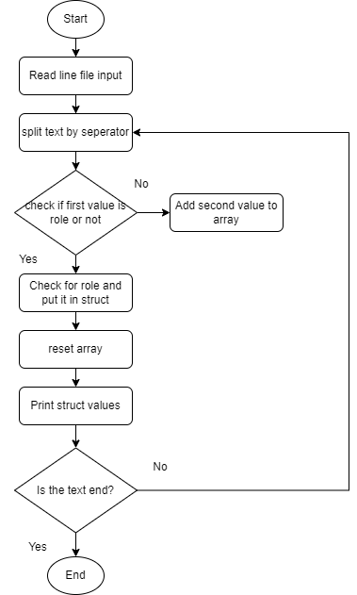

**Results:**

1. Observations
   1. The result printed out as expected
   2. The printed struct that applied fmt::Display can print out correctly

**Conclusion:** The method of using Display in traits to use for struct make printing information easier, just calling it as normal using “{}”.

**Acknowledgments:**

I acknowledge that all of the code written, and all of the result are addressed by myself, and all information are correct.

(Kasitphoom Thowongs)

**Appendix:**

**[OUTPUT FILE]**

Student: Some One

Age: 18

Skills: ["Python", " Rust", " Java", " Java Script", " HTML", " CSS", " PHP"]

Latitude: 25.07542° N

Longitude: -90.84256° W

Teacher: Another One

Age: 30

Latitude: -32.4502° S

Longitude: 13.05096° E

Engineer: SomeOne Else

Age: 25

Latitude: 25.79829° N

Longitude: 178.00369° E